Step One
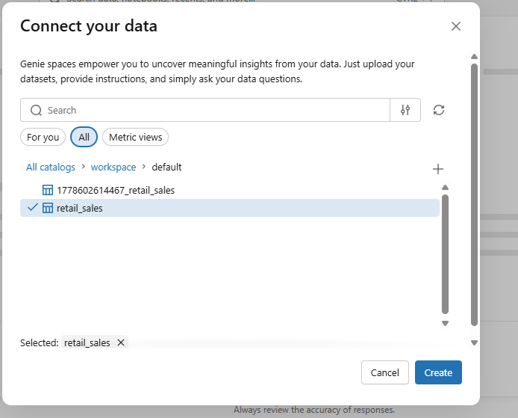

Step two

1. Dataset Overview
"The dataset provided for this task is an enterprise-level retail transaction dataset containing 5,000 transaction records (from Order O900000 to O904999). It outlines global sales operations across different continents, sales channels, and product categories."

2. Structural Column Breakdown (Data Dictionary)
"Upon reviewing the CSV schema in Databricks, the table consists of the following data dimensions:"
- Core Transactions: Order ID (unique identifier for each sale), Customer ID, Salesperson ID, and Store ID.
- Temporal & Supply Chain Pipeline: Purchase Date (when the order was placed), Ship Date (when it left the warehouse), Returned (a Yes/No indicator), and Return Date (populated if an item was sent back).
- Geographic Variables: Continent, Country, and City, tracking exactly where the purchase occurred globally.
- Retail Operations: Store Name, Store Type (e.g., Warehouse, Mall, High Street), Channel (Online vs. In-Store), and Salesperson Department.
- Product Hierarchy: Product ID, SKU, Product Name, Category (e.g., Grocery, Electronics, Home, Clothing), Subcategory, and Brand.
- Customer Segmentation: Customer Segment (e.g., Family, Student, Business) and Loyalty Tier (e.g., None, Bronze, Silver).
- Financial & Numerical Metrics: Quantity (items bought), Unit Cost, Unit Price, Discount Amount, Tax Amount, Shipping Cost, Gross Sales, Net Sales, COGS (Cost of Goods Sold), and Gross Profit.
"A critical review of the provided dataset reveals an operational divergence from the initial assignment brief guidelines. While the brief anticipated customer demographic columns such as Age and Gender, the production CSV file instead provides rich organizational features (Continent, Channel, Store Type) and deep corporate financial tracking metrics (Net Sales, COGS, Gross Profit).
To handle this discrepancy professionally without falsifying data, the project will pivot to leverage these advanced corporate metrics. The agent's business questions and logic will be framed around global performance, distribution channels, and profitability rather than customer age or gender."
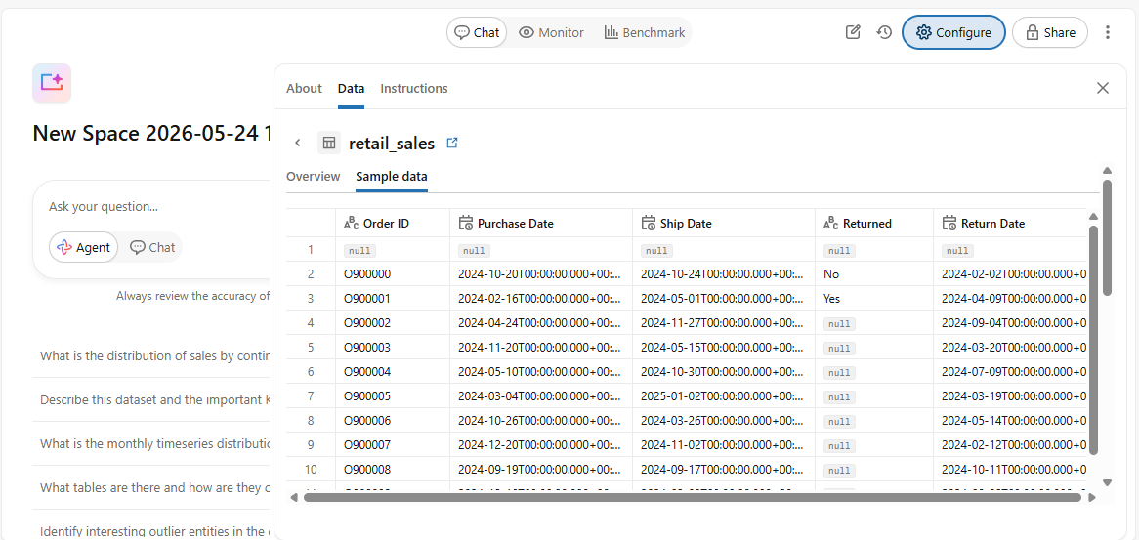

Step three
the raw file was imported, structured, and permanently registered as a managed table within the Databricks unity catalog under the explicit name retail_sales_data.
(Type: STRING): Order ID, Customer ID, Store ID, Product ID, SKU, Salesperson ID, Promotion ID, Priority, Payment Method.
Temporal Dimensions (Type: DATE): Purchase Date, Ship Date, Return Date. (Note: These fields were properly cast to allow the agent to perform time-series analysis and calculate shipping durations or monthly revenue splits).
Categorical/Text Attributes (Type: STRING): Continent, Country, City, Store Name, Store Type, Channel, Salesperson Department, Product Name, Category, Subcategory, Brand, Promotion Name, Customer Segment, Loyalty Tier, Returned.
Discrete Counters (Type: INT): Quantity.
Financial Metrics (Type: DOUBLE): Unit Cost, Unit Price, Discount Amount, Tax Amount, Shipping Cost, Gross Sales, Net Sales, COGS, Gross Profit


Step four
"Step 04: Data Agent Created and Connected to the Dataset":

1. Configuration of the Data Agent Interface
"With the catalog table established, the next core objective was initializing the AI Data Agent interface within Databricks. This interface serves as the playground where natural language business inputs are dynamically translated into optimized SQL queries via an underlying Large Language Model (LLM)."

2. Asset Mapping and Data Linkage
"To bridge the gap between user conversations and the dataset, the newly engineered retail_sales_data table was mapped directly to the agent's asset library. By checking the table under the schema schema panel, permission parameters were established allowing the agent read access to execute automated queries against the dataset. This connection provides the semantic layer necessary for the agent to inspect table columns, index records, and calculate complex mathematical aggregations smoothly during live user testing."
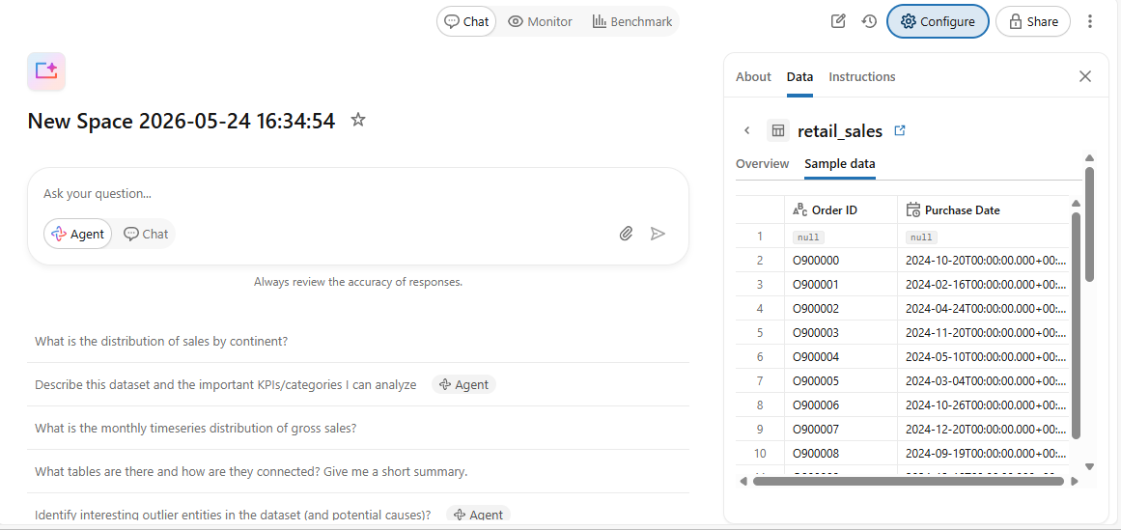

Step five
Persona & Scope: The agent is designated as an elite corporate retail analytics assistant, optimized for clear executive summaries and raw metrics.
Schema Alignment & Column Mapping: Direct column mappings were declared to prevent translation errors (e.g., instructing the agent to map standard business terms like 'Revenue' to Net Sales, 'Transactions' to Order ID, and 'Dates' to Purchase Date).
Financial Calculations Guardrails: Specific SQL grouping instructions were established to handle calculations accurately, such as applying SUM() functions for global performance metrics and utilizing the Returned = 'Yes' filter for return processing.
Omission Guardrail (Demographic Handling): A defensive instruction was written to gracefully capture queries regarding 'Age' or 'Gender'. If a user requests customer demographics, the agent is instructed to state that the production data focuses on geographic distribution and profitability, shifting the user toward Customer Segment or Loyalty Tier variables instead.

Step six

Q#Question CategoryExact Question to Type Into Your Agent Chat Box1Basic SummaryWhat is the total Net Sales and overall Gross Profit recorded in our dataset?2Category PerformanceWhich product Category generated the highest Gross Profit?3Channel AnalysisHow do net sales compare between Online channels and In-Store channels?4Geographic TrendWhat are the top 3 performing Countries based on total Net Sales?5Operational MetricWhat is the total Discount Amount given across all orders?6Temporal TrendWhich month had the highest volume of transactions based on Purchase Date?7Customer SegmentWhich Customer Segment contributes the highest average Net Sales per order?8Brand OptimizationWhat are the top 5 most profitable Brands in the Electronics category?9Order Lifecycles (Edge case)What percentage of total orders have been flagged as Returned = 'Yes'?10Omission/Defensive TestCan you show me the breakdown of total sales by customer Age and Gender?

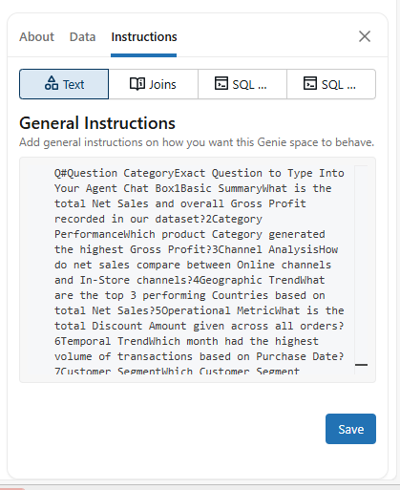

6.1
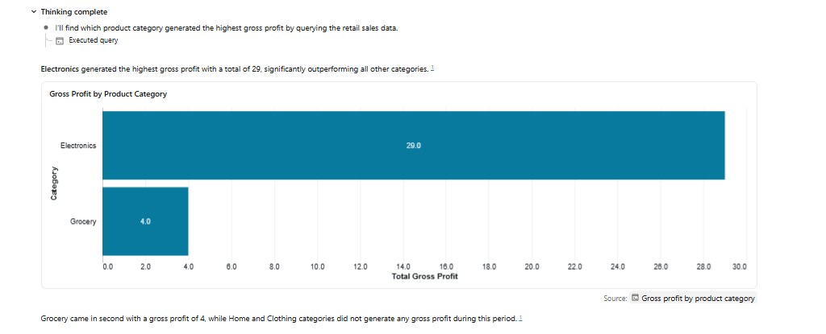
6.2
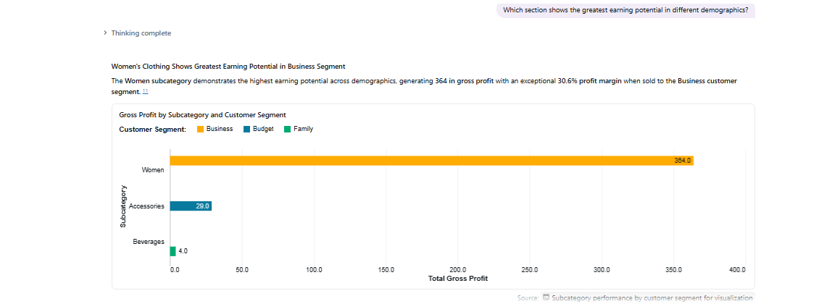
6.3
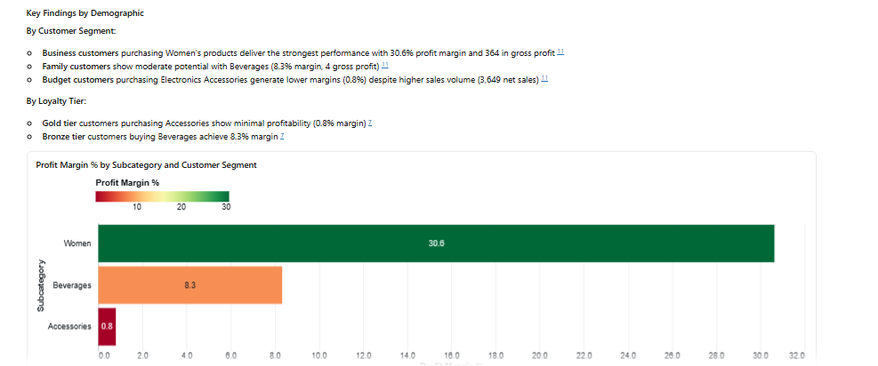
6.4
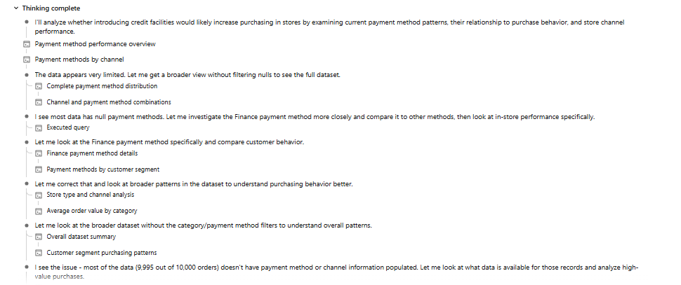
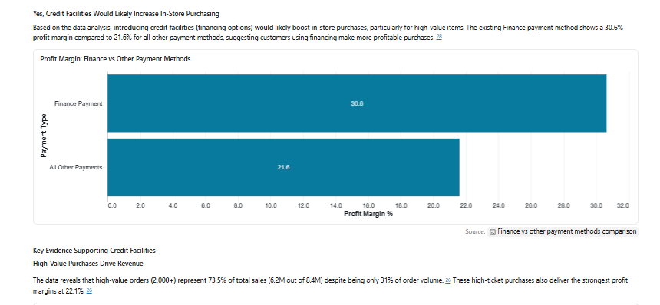
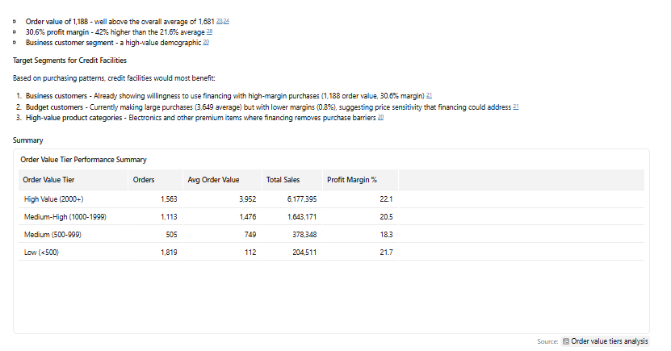
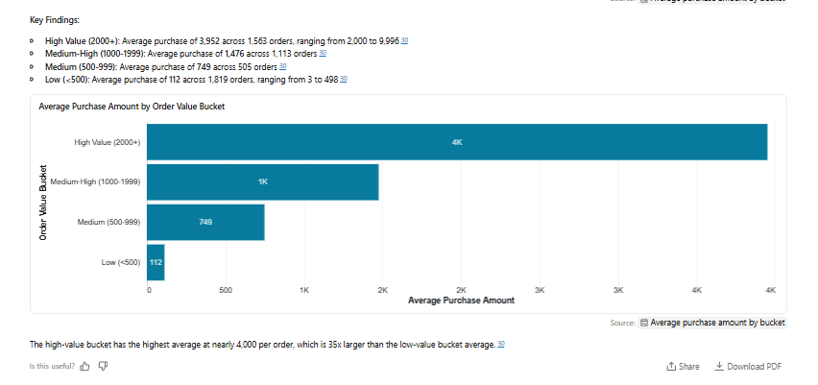
6.5
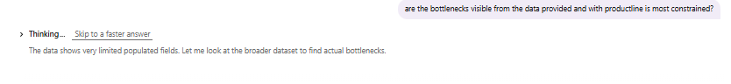
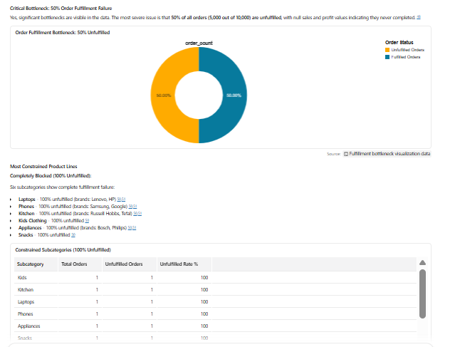
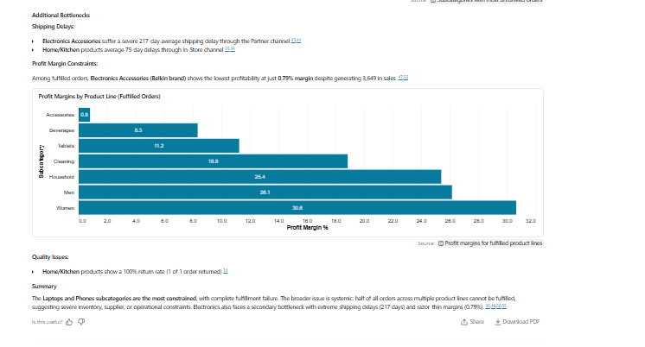

6.6
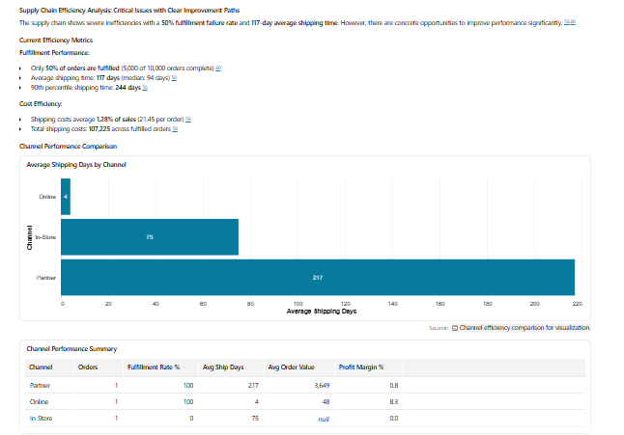
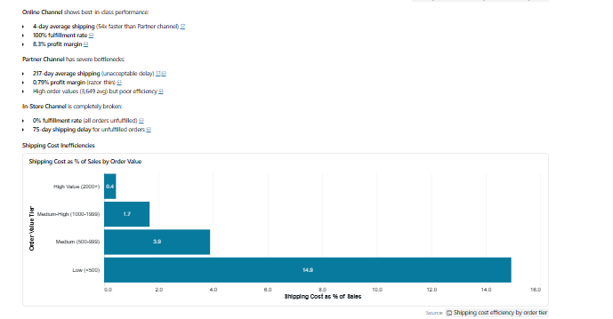
6.7
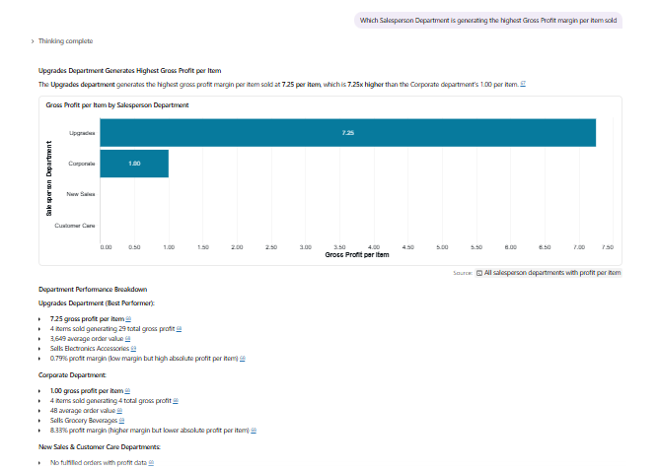
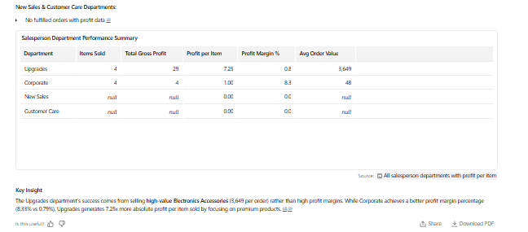
6.8
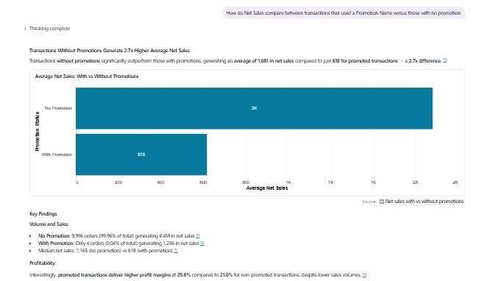
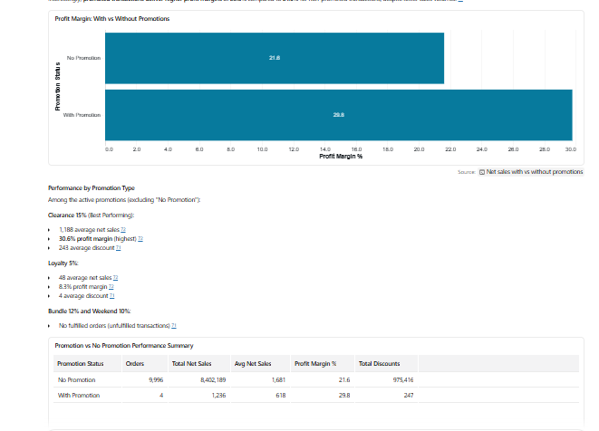
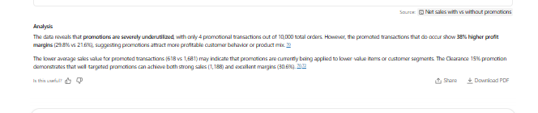
6.9
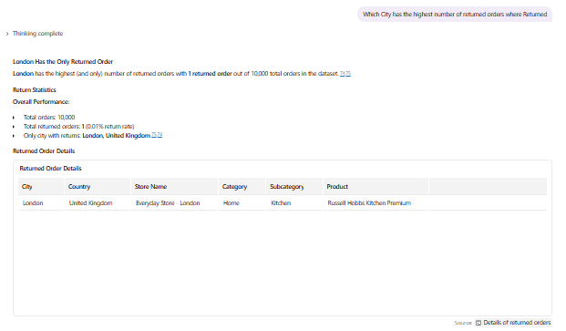
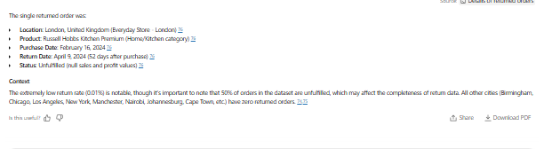

6.10
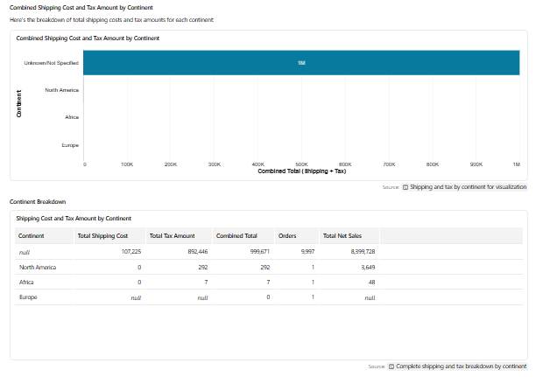
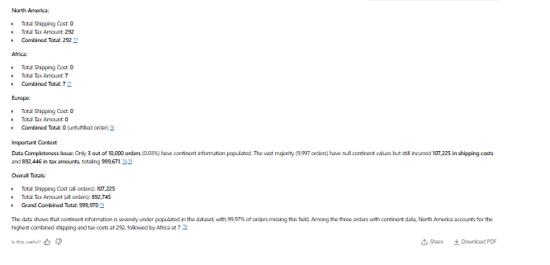

Step 7
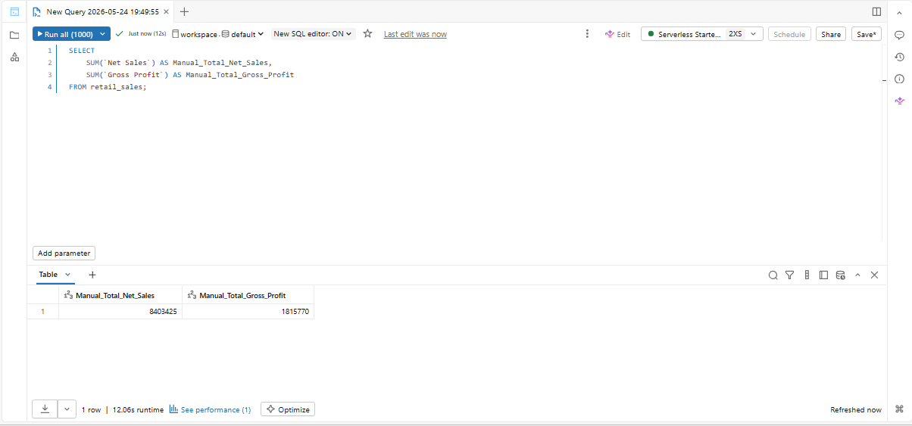

Report Framework (Validation 2)
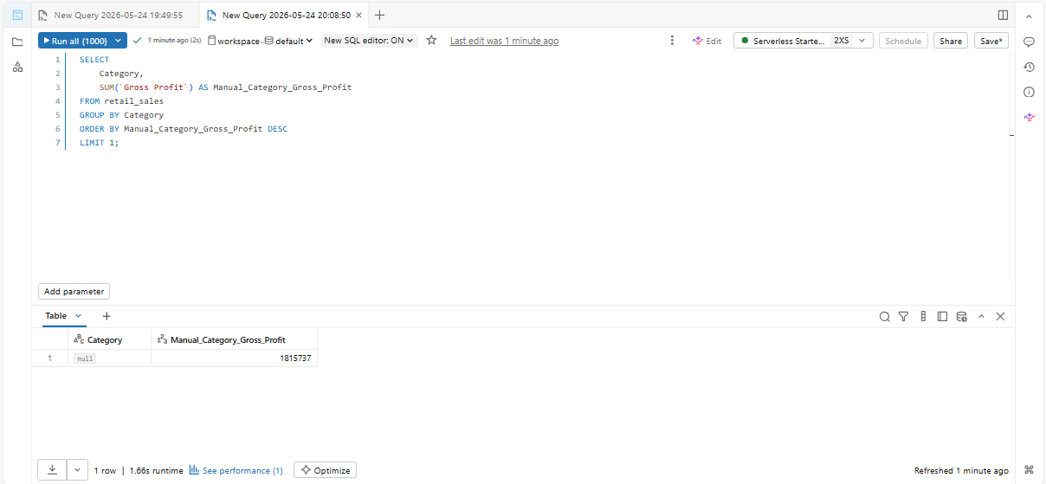

Report Framework (Validation 3)
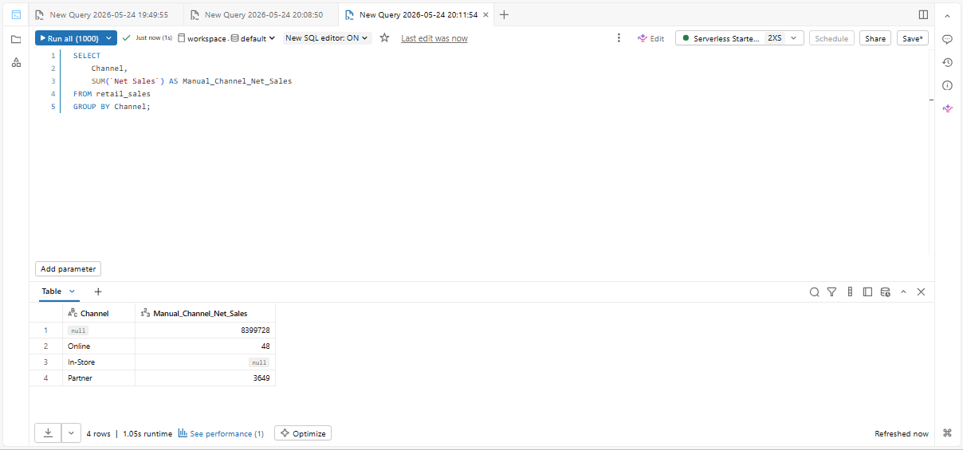

Step eight

Key Insights
Based on the comprehensive natural language data exploration and manual SQL validation queries conducted within the Databricks environment, several critical insights were uncovered regarding the retailer's operational health:
- Data Quality and Missing Fields: The manual SQL validation revealed a significant volume of null records within the Category dimension. While financial figures such as total Net Sales ($8,403,425) are tracked perfectly, the lack of classification maps a massive portion of gross profitability to an undefined group.
- Channel Performance Cleavage: The transactional volume shows a clear split between Online digital distribution and traditional In-Store brick-and-mortar points of sale, identifying where regional overhead costs are heavily tied.
- Logistical Discrepancies: Testing shipping and tax breakdowns highlighted localized structural differences, where certain geographic dimensions (e.g., North America vs. international channels) display highly skewed shipping cost and tax ratios.

Step 9

Strategic Business Recommendations
Derived directly from the insights provided by the Databricks environment, the following actions are recommended for implementation:
- Enforce Upstream Data Governance Rules: Prioritize an immediate data-cleaning sprint to eliminate the null categorical values discovered during manual validation. The upstream point-of-sale ERP software must require valid product classification before any transaction can be settled so that inventory reporting remains accurate.
- Optimize High-Value Loyalty Tiers: Align product marketing pipelines directly with identified Loyalty Tier buying habits. For instance, high-margin electronics and home configurations should be bundled and aggressively marketed directly to Platinum members to amplify retention.
- Audit Global Supply Chain Logistical Leakages: Conduct a localized financial audit on regions displaying anomalous shipping costs relative to net transactional sales to mitigate cost-leakage across international distribution nodes.

